Welcome to the 55th Georgia State Meeting
7th District of
Omega Psi Phi Fraternity, Inc.
Augusta, GA

“Omega: Celebrating Friendship, Fraternity, and Service in The Garden City”
October 4-7, 2018
Augusta Marriott at the Convention Center
2 Tenth Street, Augusta, GA 30901

Host Chapters:
Psi Omega and Upsilon Gamma Gamma

Undergraduate Chapters:
Gamma Beta (Paine College) and Omega Eta (Augusta University)

The Brothers of Psi Omega, Upsilon Gamma Gamma along with Gamma Beta and Omega Eta Chapters are honored to serve as your host for the 55th Georgia State Meeting of the Omega Psi Phi Fraternity, Inc.
The Ques of the Garden City look forward to providing outstanding facilities and displaying first-class hospitality during the meeting. In addition to the host chapters, the Brotherhood and their families will be able to enjoy all that our beautiful city has to offer.

The host hotel for the meeting is the Augusta Marriott at the Convention Center which is located at 2 Tenth Street, Augusta, GA 30901. Our goal is to have as many registered Brothers stay in the host hotel as possible. To do this, once you have registered for the meeting, you will receive an email with a link for the hotel reservation. You can only get the state meeting rate if you use the emailed link. Room rates are $120.00 a night and $7.00 per night for parking. The hotel is located Downtown with easy access to the city. You can expect all your lodging needs to be satisfied by the professional and courteous hotel staff.
As your host Chapters, we are planning a great weekend, beginning Thursday at 12:40 p.m. with a golf outing at “The River Golf Club.” The course is in North Augusta, South Carolina and is approximately 7 minutes from the Augusta Marriott Hotel. The hotel has a full feature restaurant with an excellent menu. The area is served by several excellent restaurants. On Friday night, the All BLAQUE party will be at the T-Center, which adjoins the host hotel. Registered Brothers will only need to present their badges for admission.
A hospitality room at the hotel will be opened beginning Thursday night but will be closed during plenary sessions.
We ask that you register on-line www.opp-ga.org today to attend the 55th Georgia State Meeting and that you make your room reservation. There will be no on-site registration for the meeting. Our commitment is to have an enjoyable and informative 55th Georgia State Meeting. We look forward to hosting you.
Fraternally,
The Brothers of Psi Omega, Upsilon Gamma Gamma, Beta Gamma, & Omega Eta Chapters
LOCAL CONTACTS
Brother Charles H. S. Lyons, III – 55th Georgia State Marshal - (706) 799-2131
Brother Charles Myler, Psi Omega Chapter Basileus - (706) 951-2139
Brother Chuck Walker, Upsilon Gamma Gamma Chapter Basileus- (910) 263-2381
Brother Harry Davis, Gamma Beta Chapter Basileus – (786) 375-1926

Registration Fee Summary
On-line registration closes September 16, 2018 at midnight. There will be NO ON-SITE REGISTRATION. Brothers that register after September 1, 2018 at midnight are not guaranteed a 55th Georgia State Meeting souvenir. Brothers must be registered and present to receive their souvenir (Except for emergencies approved by State Rep.). All Brothers are required to register for the 55th Georgia State Meeting and pay the appropriate fees in order to participate in any aspect of the meeting. MSP NOTE: MSP fee categories apply to Brothers who were initiated after October 8, 2017. Hotel reservation information will be emailed to you once you complete the registration process for the meeting. Registration includes your souvenir, a ticket to the Undergraduate Luncheon, Founder’s Banquet, March Down Competition, and host parties.

Delegate Form 36S (Which will be emailed to each chapter KRS) is due to the State Keeper of Records & Seal before September 16, 2018 (midnight). If your chapter KRS does not have or receive the Form 36S by September 1, 2018, please contact Bro. Torre’ Anderson, State Keeper of Records & Seal, tanderson45@comcast.net (678) 939-1404.

Registration can be completed online at the State Website: http://www.opp-ga.org

Early Registration Fees
Registration $145.00
Host Chapter $125.00
MSP (No Fees if Initiated after October 8, 2017. Brothers still must Register)

After September 2, 2018
Registration $190.00
Host Chapter $190.00
MSP $45.00
Registration Closes September 16, 2018
Additional Event Tickets
Additional Undergrad Luncheon Tickets $40.00
Additional Founders Banquet Tickets $30.00
Additional Friday Night Dance Tickets $40.00
NO ON-SITE REGISTRATION

MARCH DOWN FORM
March down will be October 6, 2018 from 8:30 PM to 9:30 PM
Please print or type — Use black ink only!
Contact Person: _________________________________________________________
Chapter Name: _________________________________________________________
Address: ________________________________________________________________
City: _____________________________ State: ________ Zip: ______________________
Home Number _____________________________ Work Number __________________________
Fax Number: ___________________________ Email Address: _____________________________
All March Down participants must be financial members of Omega Psi Phi Fraternity, Inc. Any team that exhibits any vulgar language and/or canine references will be automatically disqualified. All shows should be limited to ten (10) minutes. A cash prize will be given to the first-place winner.
Brother’s Name

Control #

Chapter

Email completed form to: Harry Davis, harrydavisjr21@yahoo.com 786.375.1926 and Bro. Rodney Brown rbrown5@bellcouth.net 404.259.2705

STATE OF GEORGIA
RULES FOR MARCH DOWN COMPETITION
- Each chapter will be represented by only one (1) team.

- Each team will consist of no more than the number of financial brothers on record for your chapter.

- Each team member must be currently enrolled and as well be in good standing with their respective college or university. Each member of the team must be a financial member in good standing with the International Headquarters (If graduate team, members w/chapter).

- Each team MUST have at least 1 registered participant from their respective chapter at the State Meeting.

- Each team MUST complete and submit a March Down Participant Form prior to the State Meeting.

- Each team will have 10 minutes to perform. The March team will have points deducted for going over the time limit.

- There will be five judges responsible for scoring and recording scores for the competition. Your team will be judged on the following criteria on a scale of 1 to 10 (10 being the highest or best score): creativity, originality, precision, uniforms, and showmanship.

- A team will be disqualified for the following reasons: Profane language, profane jesters, and degrading statements that are not acceptable for the audience or event or any act that will tarnish the image of the Omega Psi Phi Fraternity, Inc.

- Each member of the March team MUST present their Official Omega Psi Phi Fraternity membership card with a valid identification before the March Down begins.

Basileus’ Signature ____________________________________________________
Advisor’s Signature ____________________________________________________
HOUSING:
Augusta Marriott at the Convention Center
2 Tenth Street, Augusta, GA 30901

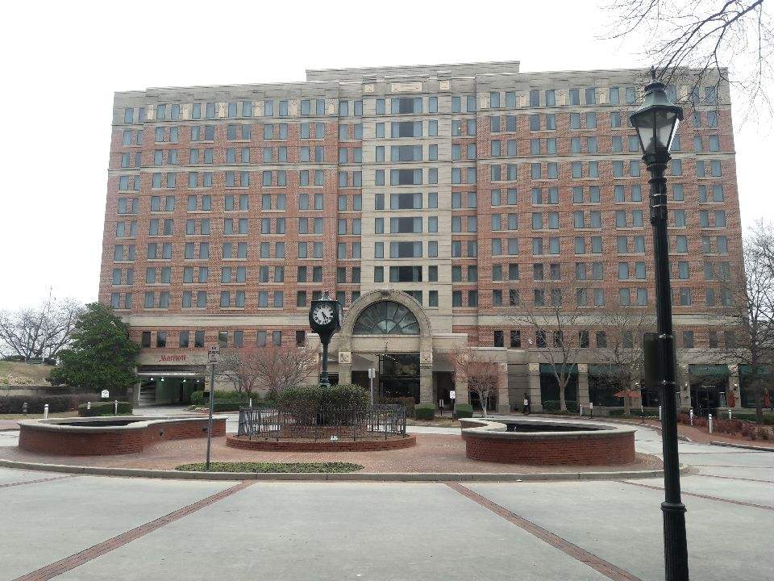

Special group rate: Last date to book 9/13/2018
Augusta Marriott at the Convention Center group room rate for the meeting will be $120.00 USD per night- Queen or Double. To reserve your room, you must register for the 55th Georgia State Meeting first. Once registered, Brothers will receive an email with the hotel reservation link to make hotel reservations.

VENDOR FORM
Please print or type. Use black ink only!

Vendor: _______________________________________________
First: _________________ Middle: _________________ Last: ___________________
Address: ____________________________________________________________
City: ___________________ State: ______________ Zip: __________________
Contact Information:
Home: ________________ Work: _______________ Fax: ___________________
Email: ____________________________________________________________
SIGNATURE: _____________________________________________________
Thank you for your patronage.
Booths Rates @ $150.00 per booth = __________________ Total: $______________________

Booths will be issued on a first come, first serve basis. Booths will be available for rental when the 55th Georgia State Meeting Registration opens. Booth rentals will be available from Thursday, October 4, 2018, through Saturday, October 6, 2018, from 8:00 a.m. to 9:00 p.m. This form must accompany the payment of the required fee and a copy of the vendor’s current license issued by Omega Psi Phi Fraternity, Inc. Each vendor will be provided two chairs and a table to use at their discretion. Note: The Fraternity or any of its Chapter members associated with the organization is not responsible for the security of your merchandise.
Payment Type: Check or Money Order, payable to Psi Omega State Meeting. Please reference Booth Rental in your Check or Money Order memo section.
Mail form to: Psi Omega Chapter Attn: Brother Charles H.S. Lyons III, P.O. Box 2507, Augusta, GA 30903.
55th GEORGIA STATE MEETING SOUVENIR ADS BOOKLET
TO: All Chapters
FROM: Charles H. S. Lyons, III, 55th Georgia State Marshal
RE: 55th Georgia State Meeting Souvenir Ads Booklet

Ads can be submitted once the 55th Georgia State Meeting Registration begins. To place an order for an ad, please complete the attached form and mail payment with submissions to Psi Omega Chapter, P. O. Box 2507, Augusta, GA 30903. Please note that Electronic submissions are preferred for best quality. Make sure you include all contact information with a copy of your ad and payment. Please note that all ads will be in color. Send all ads print ready to Brother Steven Morris at moetwo2000@hotmail.com or Brother Stan Reed at qrupt69@yahoo.com. All ads should be forwarded and paid for by September 10, 2018.
Ads Prices:
Ω Full Page $150.00
Ω ½ Page $ 75.00
Ω Business Card $ 50.00
Ω Front Inside Cover $ 400.00
Ω Back Inside Cover $ 300.00
Ω Back Cover $ 400.00
Checks should be payable to Psi Omega State Meeting and mailed to Bro. Charles H.S. Lyons, III, Psi Omega Chapter, P.O. Box 2507, Augusta, Georgia 30903. Please reference Ad in your Check or Money Order memo section.

Ad Request Information

Contact Person:
Telephone:
Company/Organization:

Indicate Preference

Ads Prices: All Ads must be print ready

Ω Full Page $150.00

Ω ½ Page $ 75.00

Ω Business Card $ 50.00

Ω Front Inside Cover $ 400.00

Ω Back Inside Cover $ 300.00

Ω Back Cover $ 400.00

Text:

Graphics: (If Yes Please Specify and Attach Copy)

Photo: Yes No

Logo: Yes No

Deadline: September 10, 2018

Golf Registration

To: Omega Golfers
From: Brother Ricardo “Rick” Daggett
RE: 55th Georgia Sate Meeting Golf Outing

We have planned a great golf outing for you to enjoy and have fun. This is a great golf course that set along the banks of the Savannah River and may present a challenge for some more than others.
When: Thursday October 4, 2018
Where: The River Golf Club
307 Riverside Boulevard
North Augusta South Carolina
Time: 12:40 p.m.
Cost: $49
Contact Information:
Brother Rick Daggett- 706 833 5034- rickd2025@aol.com
Brother Charles Myler-706 951 21- cmyler0821@yahoo.com
Brother Staten Heard-248 709 1943- statenque@aol.com

Make your Check or Money Order payable to Psi Omega State Meeting: Please reference Golf Registration in your Check or Money Order memo section by September 27, 2018, to Bro. Charles H.S. Lyons, III, Psi Omega Chapter, P.O. Box 2507, Augusta GA 30903.

Ωuettes of Augusta
55th GEORGIA STATE MEETING
QUETTE REGISTRATION

TO: QUETTES
FROM: Ms. Jennifer Ross
RE: 55TH Georgia State Meeting
Ladies:
We have a fun filled weekend planned for you while your significant others take care of Omega business. Please complete the form below.
Send the completed form with your registration fee of $100.00. Please reference Quette Registration in your Check or Money Order memo section, payable to Psi Omega State Meeting to Bro. Charles H.S. Lyons, III, Psi Omega Chapter, P. O. Box 2507, Augusta, GA 30903, by September 16, 2018.

NAME: ________________________________________________
ADDRESS: _____________________________________________
___________________________ ZIP: ______________
PHONE: ________________________________________________
E-MAIL: _______________________________________________

For more information:
Contact-Jennifer Ross -706-832-3850 or jross0429@gmail.com

We look forward to renewing old acquaintances and creating new ones.

All Black Dance

To: Omegas
From: Brother Bernard Dawson
RE: 55th Georgia State Meeting

We have an All Black Everything at this All Black Dance. Registered Brothers will be admitted without cost after presenting Registration Badge.

